

Google chrome

(Browser)

Software Documentation and Technical Writing

|  |  |
| --- | --- |
| رنا احمد الشاردي | 44410337 |
| اريام محمد الكديسي | 444011065 |

**Abstract:**

In this project we will talk about Google Chrome browser, browser requirements, the tasks it performs, what is the purpose of this browser, and users’ opinions.

**Keywords:**

Web browser , Problems Solves.

**Table of contents:**

1.1 INTRODUCTION

1.2 The REQUIRMENTS

1.3 Tasks the software can do

1.4 DETERMINE THE PROGRAM PURPOSE

1.5 CONDUCT A SURVEY OR INTERVIEW

1.6 RESEARCH EXISTING PROGRAMS

1.7 GoogleChrome system architectures

1.8 Data model

1.9 Outline technical specification

1.10 Git Hub

1.11 Conclusion

1.12 REFERENCES

1.1

**Introducing**

Google Chrome is a free web browser developed by Google, first released in 2008. It is known for its speed, simplicity, and user-friendly design, quickly becoming one of the most popular browsers worldwide. Chrome is built on the open-source Chromium project and uses the Blink rendering engine, offering seamless performance across various devices and platforms. With features like tabbed browsing, integrated search, and support for extensions, Chrome enhances the user experience while maintaining robust security measures. Its frequent updates ensure the browser stays optimized for the latest web technologies and security standards.

1.2

**The Requirements**

* System Requirements

Non-functional requirements

* Easy to use.
* processing orders in 0.3 seconds 24/7 access.
* information protection.
* handling a large number of orders and users.
* User Requirements

Functional requirements

* Users must have the ability to register in the system and create a personal account .
* The system must provide a search box and allow the user to enter various search criteria .
* The user can send messages to the support team to solve problems .
* Users should be able to submit ratings and reviews .
* The system should support multiple languages to accommodate users from different regions.

1.3

**Tasks the software can do**

1. Web Browsing: Allows users to visit websites, search for information, and navigate the internet seamlessly.

2. Add-ons and Extensions: Users can customize their browsing experience by adding extensions that enhance functionality, such as ad blockers, password managers, and productivity tools.

3. Cross-device Sync: With a Google Account, users can sync bookmarks, history, and settings across multiple devices, ensuring a seamless experience whether on desktop, tablet, or smartphone.

4. Incognito Mode: This feature enables private browsing, allowing users to browse the web without saving their history, cookies, or site data, providing an additional layer of privacy.

‏

1.4

**DETERMINE THE PROGRAM PURPOSE**

Google Chrome exists as a web browser designed to provide users with fast, secure, and user-friendly access to the internet. Its primary purpose is to allow individuals to navigate and interact with web content such as websites, applications, and multimedia.

Problems It Solves:

1. Fast Browsing: Chrome is designed to load websites quickly, utilizing its efficient engine to reduce delays.

2. Security : It addresses the need for secure internet usage by including features such as Safe Browsing, sandboxing, and automatic updates to protect users from malware, phishing, and other online threats.

3. Compatibility : Chrome supports modern web standards, allowing it to run the latest web applications and media content smoothly across different platforms.

4. Customization : Through extensions and themes, Chrome meets the need for customization, allowing users to enhance their browsing experience with added functionality.

5 .Cross-Device Sync : Chrome solves the problem of accessing bookmarks, history, and passwords across multiple devices by providing synchronization through Google accounts.

 Needs It Addresses:

Efficiency: Users need a browser that performs efficiently with minimal lag.

Security : Protecting personal information while browsing is a critical need.

Usability : Chrome provides an intuitive and easy-to-navigate interface for users.

Consistency Across Devices: Users benefit from the ability to use the browser seamlessly across phones, tablets, and computers with the same settings and data.

1.5

**Conduct a Survey or interview**

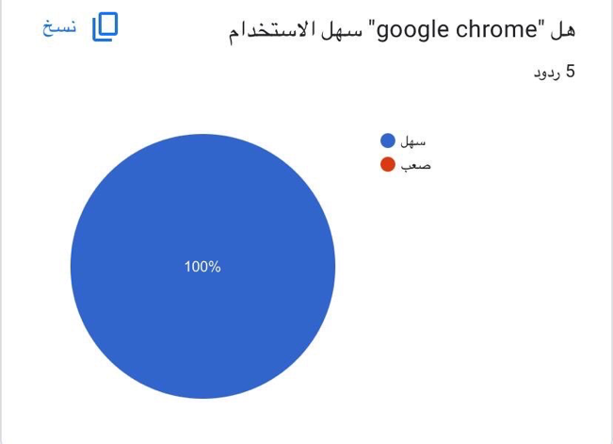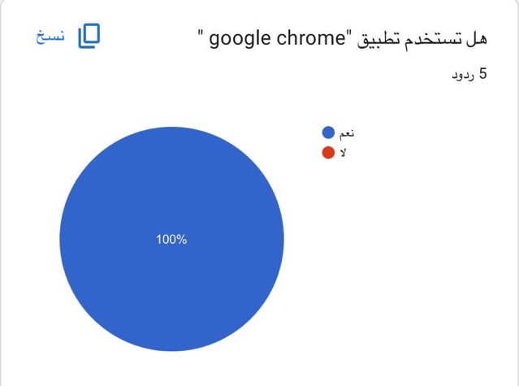We conducted a survey and this survey showed that there is a large percentage of people using Google Chrome, and that Google Chrome users are satisfied with the browser’s services and ease of use, and that there are suggestions theywanted to improve Google Chrome.

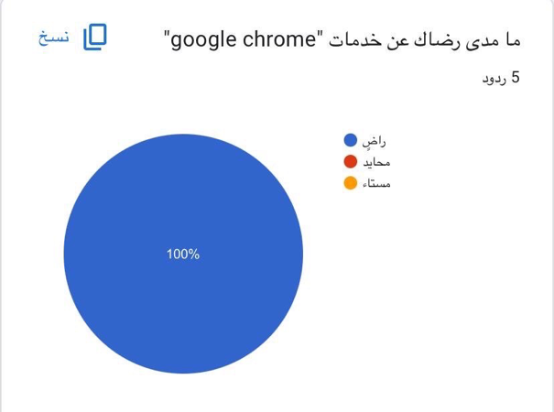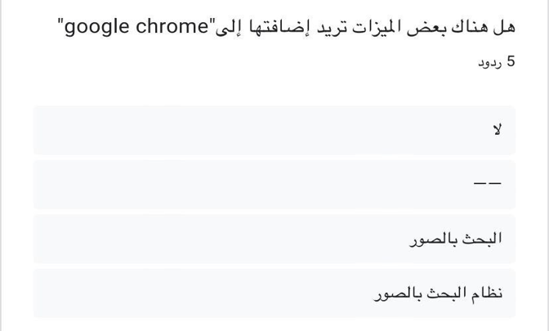

1.6

**Research Existing Program**

There are many browsers similar to Google Chrome, including

* Microsoft Edge:

Advantages:

* Microsoft Edge comes with a reading mode, which allows you to remove all the extra unwanted stuff on a web page other than the main text such as images, ads, and sidebars, so it gives you an experience closer to reading a newspaper, reading mode removes formatting to allow for easier reading on devices.
* Microsoft Edge comes with high speed, speed is one of the most important aspects to consider when deciding which browser should become your default option, according to Microsoft, Microsoft Edge is the fastest browser on the market, and you can also create a Microsoft account easily.
* Microsoft Edge is an application and not a system program, and it will be the default browser for both the PC and mobile versions of Windows 10, replacing Internet Explorer 11, since it has its own rendering engine, it is unlikely to appear at all on iOS or Android devices.

 Disadvantages:

* Microsoft Edge has no extension support, no extensions means no mainstream adoption, the only reason you probably won’t make Edge your default browser, you’ll really miss out on your extensions, there’s a lack of full control, and an easy option to switch between search engines is also missing.
* Lack of privacy Microsoft Edge used to store private data when browsing in InPrivate mode, so it turns out InPrivate mode wasn’t private at all, Cortana is another worrying feature, not just for Edge but for Windows 10 as a whole, many of the vulnerabilities in IE still exist in Microsoft Edge, and Edge has introduced some of its own, such as the recent PDF exploit.
* Microsoft Edge doesn’t display the protocol used to connect to the active site, and the only indicator it gives that you’re connected to a secure site (https) is a padlock icon in front of the address, and the secure icon should use color indicators (green and red) because that’s how all other browsers handle these visuals.
* Safari:

Advantages:

* Tabs are automatically synced between Mac and iPhone, using iCloud, similar to the bookmark sharing feature on Google Chrome.
* Ability to share site links with a single click to email, social media, and share sites directly between Android and iPhone.
* Improves readability of pages that don’t display well on the device, most likely due to incompatibility with the iPhone, and enables

Reader View to improve your experience.

Disadvantages:

* Limited support for add-ons, slow in releasing add-ons provided by Google Chrome.
* Only available for Apple and designed for Apple devices only and closed source.
* Cannot display icons and thus it is difficult for the user to distinguish between existing tags.

Comparison:

* Google Chrome:

It is a giant drainer of device resources, compared to Apple Safari and Microsoft Edge which are more efficient in their use of RAM, however, the specific RAM consumption of each browser will vary depending on the factors mentioned above.

For example, if you have a lot of tabs open and extensions installed, Chrome will likely consume more RAM than Safari or Edge, conversely, if you have a few tabs open and no extensions installed, Chrome may be more efficient than the other two browsers.

However, Google is actively working to alleviate Chrome’s memory issues, and the Chrome Task Manager allows users to identify and terminate memory-intensive tabs or extensions. Additionally, introducing features like “Ignore Tabs” and “Freeze Tabs” helps reduce the impact of inactive tabs on memory usage.

* Safari:

Safari, Apple’s default web browser, is known for its efficiency and optimization for macOS and iOS devices, and Apple has focused on keeping Safari’s RAM consumption low while providing a smooth browsing experience.

Safari uses a different approach compared to Chrome, as it uses a process hierarchy that groups related tabs into a single process. This grouping reduces memory load by sharing resources between tabs in the same group.

Safari’s low RAM consumption is particularly noticeable on devices with limited memory, such as iPhones and iPads, noting that Apple’s tight integration between hardware and software enables Safari to optimize resource allocation, resulting in efficient browsing even on devices with modest memory capacities.

* Microsoft Edge:

Microsoft Edge has undergone a major transformation in recent years, with the new Chromium-based Edge browser inheriting some of Chrome’s memory consumption patterns, but Microsoft has made efforts to improve its performance.

Like Chrome, Chromium-based Edge uses a per-tab processing model, which contributes to increased RAM usage when multiple tabs are open. However, Microsoft has implemented features to reduce memory consumption, such as “sleeping tabs,” which put inactive tabs in a low-resource state to free up memory.

Microsoft has also improved its memory management, ensuring that Edge frees up unused memory more efficiently. This reduces the overall size of the browser and prevents unnecessary memory consumption.

1.7

**Google Chrome system architectures**

1.Multi-Process Architecture

* Processes: Chrome uses a multi-process model where each tab runs in its own process. This enhances stability and security; if one tab crashes, it doesn't affect the others.
* Renderer Process: Each tab typically runs a separate renderer process which is responsible for rendering web pages.
* Browser Process: This main process manages the user interface and handles interactions with the operating system and the network.

2.Blinks and V8 Engine

* Blink: The rendering engine responsible for parsing HTML, CSS, and executing JavaScript.
* V8: JavaScript engine that compiles JavaScript into machine code for faster execution.

3.User Interface Layer

The browser's user interface is handled by the browser process, which includes tabs, address bar, and settings.

4.Networking

Chrome manages network requests using a dedicated networking stack, which includes features like HTTP/2 and QUIC for improved performance and security.

5.Security Features

* Sandboxing: Each renderer process is sandboxed, limiting its access to the system to prevent malicious activities.
* Site Isolation: Enhances security by ensuring that different websites run in separate processes, reducing the risk of cross-site attacks.

6.Extensions and Plugins

Chrome supports various extensions, which run in separate processes to maintain stability and security.

7.Storage and Caching

Chrome uses several storage mechanisms, including IndexedDB, localStorage, and service workers for caching resources to improve performance.

8.Performance Optimization

Features like lazy loading, prefetching, and aggressive caching help to speed up browsing.

1.8

**Data model**

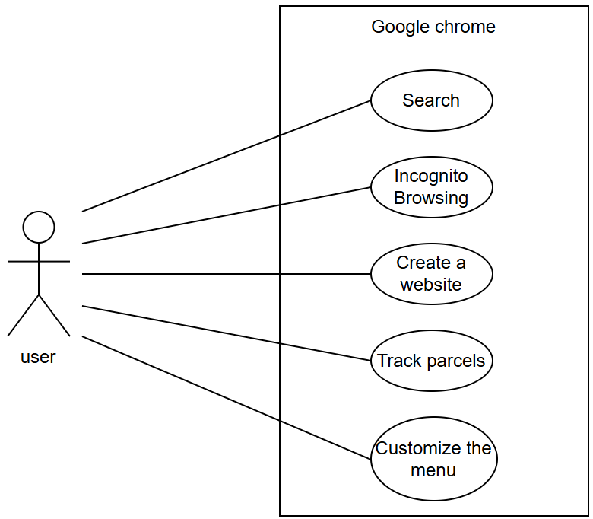

1.9

**Outline technical specification**

Your computer should meet the minimum system requirements before you install and use Chrome browser.

* Windows

To use Chrome browser on Windows, you'll need:

* Windows 10 or later or Windows Server 2016 or later
* An Intel Pentium 4 processor or later that's SSE3 capable

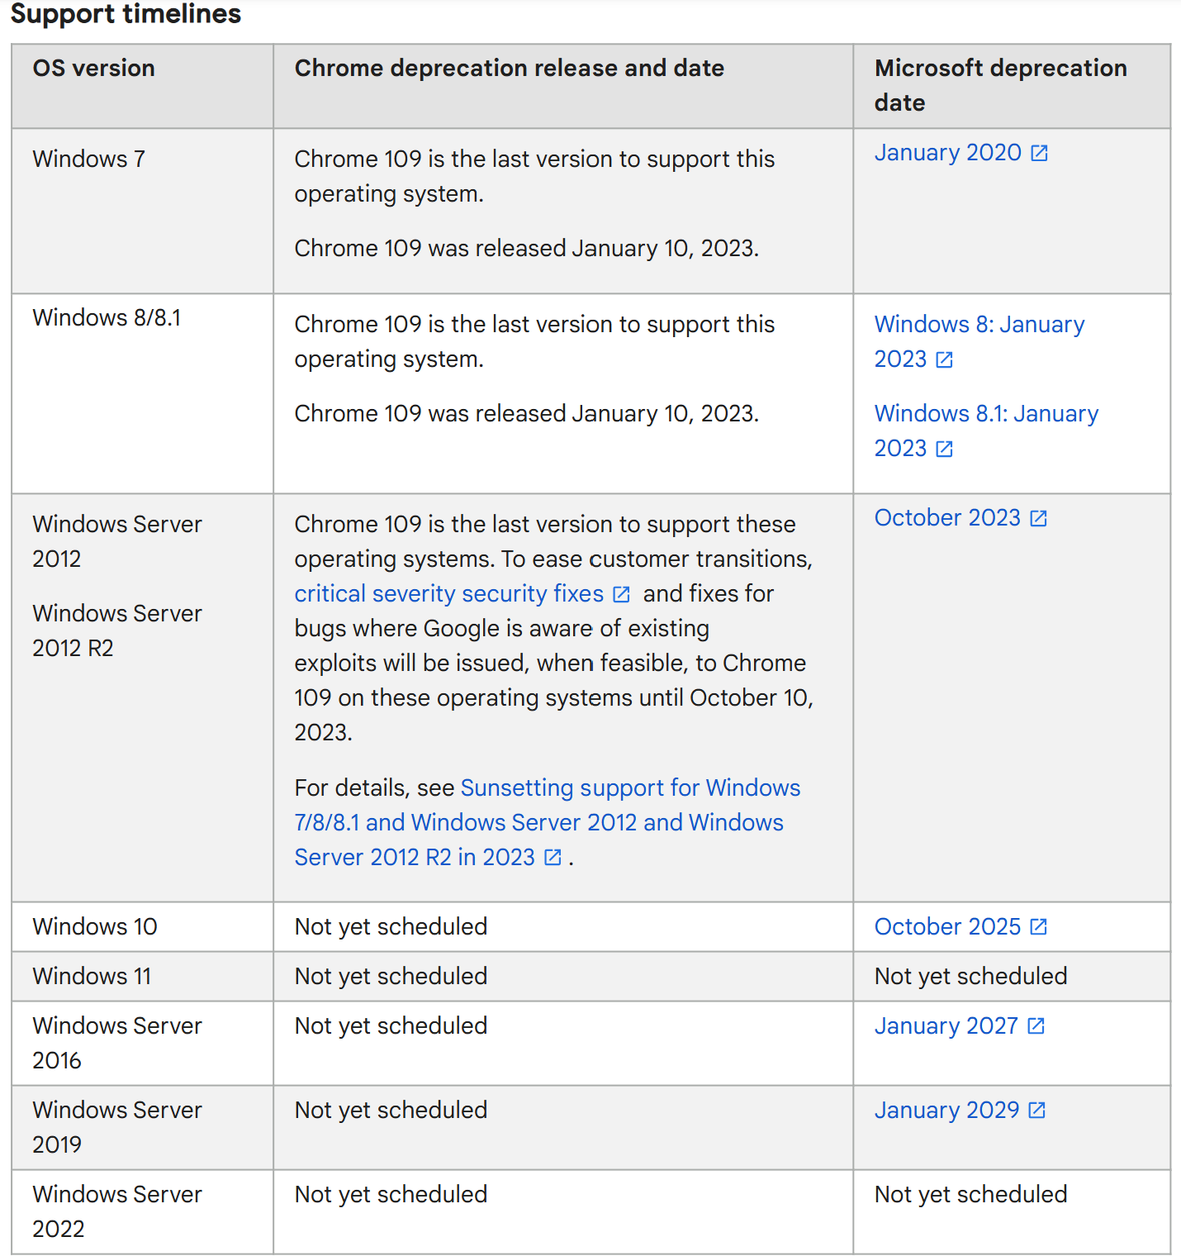

* Mac

to use Chrome browser on Mac, you'll need:

* macOS Big Sur 11 and up
* Linux

To use Chrome browser on Linux, you'll need:

* 64-bit Ubuntu 18.04+, Debian 10+, openSUSE 15.5+, or Fedora Linux 39+
* An Intel Pentium 4 processor or later that's SSE3 capable
* Android

To use Chrome browser on Android, you'll need:

* Android 8.0 Oreo

1.10

**The Git Hub**

<https://github.com/aryamalkdisi/google-chrome.git>

1.11

**Conclusion**

This project includes a lot of important information about Google Chrome, its internal structure, and how to use it.

1.12

**References**

* Monis Hawass. <https://www.youm7.com/story/2023/8/23/%D8%A3%D9%81%D8%B6%D9%84-%D9%85%D8%AA%D8%B5%D9%81%D8%AD-%D9%83%D9%85%D8%A8%D9%8A%D9%88%D8%AA%D8%B1-%D9%85%D9%85%D9%83%D9%86-%D8%AA%D8%B3%D8%AA%D8%AE%D8%AF%D9%85%D9%87-%D9%85%D8%A7-%D8%A7%D9%84%D9%81%D8%B1%D9%88%D9%82-%D8%A8%D9%8A%D9%86-%D9%83%D8%B1%D9%88%D9%85-%D9%88%D8%B3%D9%81%D8%A7%D8%B1%D9%8A/6280261>
* Dina Mahmoud. <https://www.bing.com/ck/a?!&&p=c90cd477f04bad8cJmltdHM9MTcyODQzMjAwMCZpZ3VpZD0zY2MxYjZjOC1jMjZjLTYwOGYtMzQ0Yi1hNGY2YzM4YTYxZWQmaW5zaWQ9NTI0MQ&ptn=3&ver=2&hsh=3&fclid=3cc1b6c8-c26c-608f-344b-a4f6c38a61ed&psq=%d9%85%d9%8a%d8%b2%d8%a7%d8%aa+%d9%88%d8%b9%d9%8a%d9%88%d8%a8+%e2%80%9d+%d9%85%d8%a7%d9%8a%d9%83%d8%b1%d9%88%d8%b3%d9%88%d9%81%d8%aa+%d8%a5%d9%8a%d8%af%d8%ac&u=a1aHR0cHM6Ly93d3cuYWxtcnNhbC5jb20vcG9zdC85OTQ5MTU&ntb=1>
* Content Team.

<https://nl7za.com/%d8%a7%d9%84%d8%aa%d9%82%d9%86%d9%8a%d8%a9/%d9%85%d8%a7-%d9%87%d9%88-%d9%85%d8%aa%d8%b5%d9%81%d8%ad-%d8%b3%d9%81%d8%a7%d8%b1%d9%8a-%d9%88%d9%85%d8%a7-%d9%87%d9%8a-%d9%85%d9%85%d9%8a%d8%b2%d8%a7%d8%aa%d9%87-%d9%88%d8%b9%d9%8a%d9%88%d8%a8%d9%87/>

* Google Chrome browser.